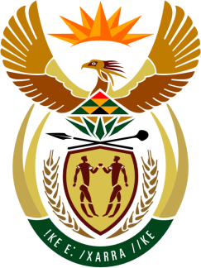

SOUTH AFRICAN PERMANENT MISSION
TO THE UNITED NATIONS
AND OTHER INTERNATIONAL ORGANISATIONS

35th SESSION OF THE WORKING GROUP ON THE
UNIVERSAL PERIODIC REVIEW

REView of GUINEA-BISSAU

24 JANUARY 2020

PALAIS DES NATIONS

Check against delivery

President,

My delegation welcomes the distinguished delegation of Guinea-Bissau to this UPR Session.

In order to ensure progress in promoting and protecting human rights, we respectfully recommend that Guinea-Bissau:
- Finalise the revision of the Constitution and ensure that it is aligned with the country’s treaty obligations.
- Fully operationalise tribunals and prosecution offices to ensure the adequate delivery of justice and countering of corruption.
- Adopt and implement a comprehensive transitional justice and reconciliation plan.
- Take steps to enhance agricultural productivity, the delivery of housing and poverty relief.

President,

South Africa welcomes the provision of basic human rights training to all military units. We are encouraged by the government’s efforts to reform the education curriculum and include content on human rights. We encourage the government to complete the revision of the charter of the National Human Rights Commission.

We also urge the government to develop robust and effective institutions that support constitutional democracy, and to address cyclical institutional crises that continue to undermine the normal functioning of the state and hinder the consolidation of the rule of law, impacting on the promotion and protection of human rights.

We wish the delegation of Guinea-Bissau all success in this review session.

I thank you.

