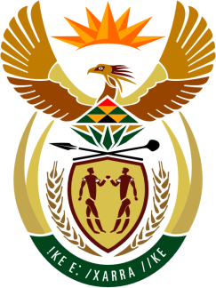

SOUTH AFRICAN PERMANENT MISSION
TO THE UNITED NATIONS
AND OTHER INTERNATIONAL ORGANISATIONS

35th SESSION OF THE WORKING GROUP ON THE
UNIVERSAL PERIODIC REVIEW

REView of LESOTHO

22 JANUARY 2020

PALAIS DES NATIONS

Check against delivery

President,

My delegation welcomes the distinguished delegation of the Kingdom of Lesotho to this UPR Session.

In order to ensure progress in promoting and protecting human rights, we respectfully recommend that Lesotho:
- Fully operationalise the National Human Rights Commission in line with the Paris Principles.
- Expedite the establishment of processes to domesticate international human rights instruments ratified by the country.
- Strengthen efforts to ensure access to health services for people in rural areas.
- Finalise the Older Persons Protection Bill to ensure the protection and promotion of their human rights.

President,

South Africa is encouraged by the government’s efforts to address gender-based violence, including through the Gender Development Policy 2018-2028; by extensive consultation on the draft Law against Domestic Violence; and by partnerships set up to address human trafficking.

We wish our sister country of Lesotho all success in this review session.

I thank you.

