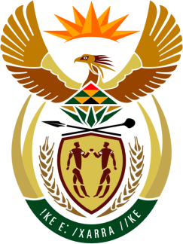

SOUTH AFRICAN PERMANENT MISSION
TO THE UNITED NATIONS
AND OTHER INTERNATIONAL ORGANISATIONS

35th SESSION OF THE WORKING GROUP ON THE
UNIVERSAL PERIODIC REVIEW

Review of Guinea

21 January 2020

PALAIS DES NATIONS

Check against delivery

Vice President,

South Africa welcomes the distinguished delegation of Guinea to this UPR Session. South Africa wishes to make the following recommendations:

- The Government to expedite and strengthen the implementation of its poverty reduction strategies, with a particular focus on children.

- Ratify the Optional Protocol to the Convention on the Elimination of All Forms of Discrimination against Women (OP-CEDAW).

- Continue to strengthen measures in combatting violence against women and girls, in particular against the practice of female genital mutilation (FGM).

South Africa welcomes and congratulates Guinea for signing and ratifying the following instruments: The Convention on the Elimination of All Forms of Discrimination against Women (CEDAW); The Convention on the Rights of the Child (CRC) and the Convention on the Rights of Persons with Disabilities.

South Africa wishes Guinea a successful review.

I thank you.

