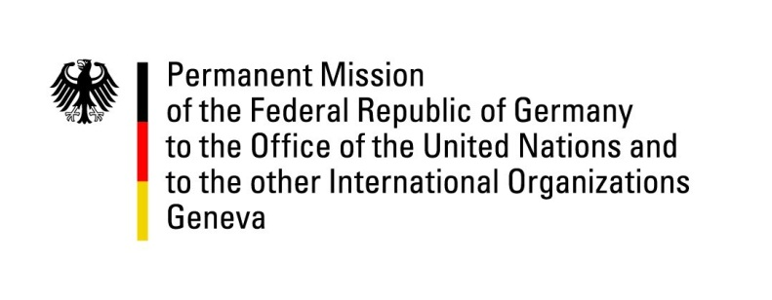

United Nations Human Rights Council

35th Session of the UPR Working Group

Geneva, 27 January 2020

Recommendations and advance questions to
Sweden

Mrs. President,
Germany welcomes the delegation of Sweden to the third cycle of the UPR.

Germany appreciates the efforts of the Swedish Government and achievements made since 2015 in further promoting human rights and gender equality. We welcome in particular the adoption of the national plan to combat racism, similar forms of hostility and hate crime in 2016 and the decision of the Parliament to incorporate the Convention of the Rights of the Child into national law as of January 1st 2020.
To continue on this path, Germany recommends the government of Sweden to:
- Take steps to overcome the obstacles that prevent the effective prosecution of hate speech, such as hate speech manifested in constitutionally protected media and strengthen efforts to properly enforce the legislation prohibiting agitation against racial, religious and ethnic minorities.
- Ratify the Third Optional Protocol to the Convention on the Rights of the Child on a communications procedure (OP-CRC-IC).

Thank you.
GERMAN ADVANCE QUESTIONS to SWEDEN:
- Which questions does Sweden have regarding the ratification of the Third Optional Protocol to the Conventions on the Rights of the Child on a communications procedure (OP-CRC-IC)? What concrete steps did Sweden take since the second cycle of the UPR to clear up these
questions?
- The European Commission against Racism and Intolerance has recently recommended Sweden to conduct widespread awareness-raising activities aimed at conveying to the general public the value of the indigenous Sami culture as an integral part of Scandinavia and its cultural heritage. Could you elaborate on how the Government will realise such awareness-raising activities on indigenous Sami in order to combat discrimination, hate crimes and prejudiced behaviour by non-Sami?

