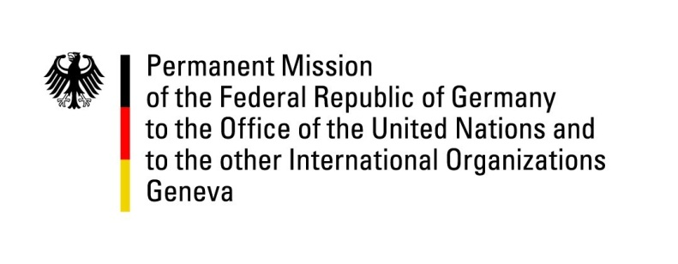

United Nations Human Rights Council

35th Session of the UPR Working Group

Geneva, 22nd January 2020

Recommendations and advance questions to
Spain

Madam President,
Germany welcomes the delegation of Spain.

We commend Spain for the efforts made in adopting the “Action Plan to Combat Hate Crimes” as well as progress made on access to the health system.

However, Germany remains concerned about bottlenecks in the asylum system and a potentially very broad interpretation of the concept of "public security and order" through the law on public security.

Germany recommends to:
- Reform the Asylum Act and establish accelerated and effective procedures, recruit new administrative personnel, establish sector-specific training of staff and renew technical systems.
- Ensure that the implementation of Articles 36.6 and 37.4 of the Public Security Act, as well as the implementation of Real Decreto-Ley 14/2019 do not counteract the right to civil protest.

Thank you, Madam President.
GERMAN ADVANCE QUESTIONS TO SPAIN:
- What changes to the asylum law has Spain planned in view of the increasing number of asylum seekers? What measures are planned for the expansion of accommodation facilities for asylum seekers?
- Does Spain plan to amend the Amnesty Law so that potential crimes committed from the period up to 1976 can be charged?

