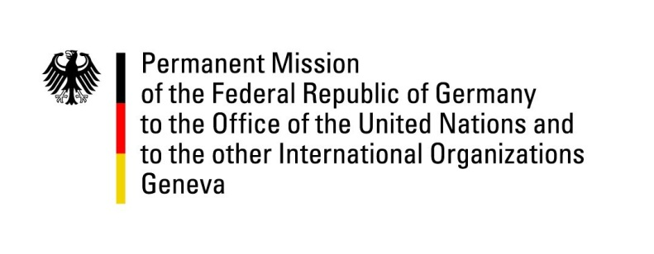

United Nations Human Rights Council

35th Session of the UPR Working Group

Geneva, 22 January 2020

Recommendations and advance questions to
Lesotho

Madame President,

Germany welcomes the delegation of Lesotho to the third cycle of the UPR.

Germany commends Lesotho for efforts in its ongoing national reform process and the establishment the National Reforms Authority.
At the same time, Germany expresses its concern about the recent increase in police violence, which has led to the death of several persons in police custody.
Germany recommends:
- To ratify the OP-CAT.
- Take effective measures to prevent further acts of torture and other forms of police violence and to bring perpetrators of such crimes to justice.
- Ratify the third Optional Protocol to the Convention on the Rights of the Child on a communications procedure, fully implement the Children's Protection and Welfare Act, and ensure effective law enforcement.
- Strengthen mechanisms to investigate cases of forced labor, in particular the Child and Gender Protection Unit and increase efforts to ensure the lawful prosecution of perpetrators of trafficking, exploitation and abuse.
- Implement legal reforms to protect the human rights of all persons irrespective of their sexual orientation and gender identity.
Thank you, Madame President.

GERMAN ADVANCE QUESTIONS to LESOTHO:
- Noticing with appreciation the progress the Government of Lesotho has made in establishing a National Human Rights Commission. However, efforts are still needed in order for it to be in full compliance with the Paris Principles. How does Lesotho plan to guarantee the effective independence of the commission?
- Following up on our recommendation made during the last UPR cycle regarding comprehensive measures against gender-based violence: What is the current status quo with regard to the establishment of victim support institutions. What kind of support is currently being granted to victims of gender-based violence?

