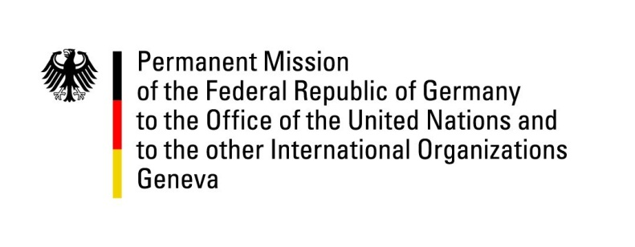

United Nations Human Rights Council

35th Session of the UPR Working Group

Geneva, 21 January 2020

Recommendations and advance questions to
Lao People’s Democratic Republic

Madam President,
Germany welcomes the progress Laos has made in implementing international human rights instruments and that Laos has repeatedly hosted Special Rapporteurs.
Germany remains concerned about ongoing restrictions on freedom of expression, association and assembly.
Germany recommends to:
- End the arbitrary arrests of individuals for exercising their right to freedom of opinion and expression, including of those who peacefully criticize the government, speak out about negative impacts of infrastructure and investment projects or expose instances of corruption.
- Conclude the process of ratification of the ICPPED quickly, and investigate all cases of enforced disappearances including the case of Sombath Somphone, and of Laotians abroad, and bring perpetrators to justice.
- Establish a national human rights institution in accordance with the Paris Principles.
- Ensure that the adoption and enforcement of laws, including the Land Law of 2019, and implementation of policies in land management and use, are consultative, transparent and fully compliant with international human rights law and standards.
Thank you, Madam President.
GERMAN ADVANCE QUESTIONS TO LAO PEOPLE’S DEMOCRATIC REPUBLIC:
- What concrete measures does the Lao PDR intend to take to protect and strengthen human rights, particularly with regard to freedom of assembly, expression and freedom of press?
- Which steps have been taken to ratify the Convention on Enforced Disappearances (ICPPED)?
- After more than seven years of disappearance of the civil society activist Sombath Somphone, what needs yet to be done to clear up the case and conclude the investigation?
- Which measures have been taken to provide compensation and acquisition of land for those affected by enforced loss of land, and to protect the right to possession of inherited land, in accordance with Decree 84/PM as of 2016 and the Law on Land as of 2019?
- Which additional support has the Government of Laos granted to families in poverty, disadvantaged groups and ethnic groups in order to provide equal access to education, in compliance with Article 6 of the Law on Education?

