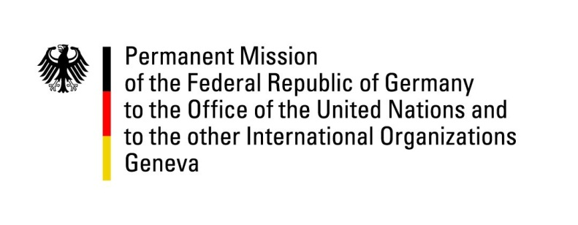

**United Nations Human Rights Council**

**35th Session of the UPR Working Group**

**Geneva, 20 January 2020**

**Recommendations and advance questions to**

**Kyrgyzstan**

Mr. President,

Germany welcomes the delegation of Kyrgyzstan.

We commend Kyrgyzstan for the efforts made in combating torture and ill-treatment. In general, we have taken note of the current efforts to strengthen children's rights, in particular the reduction of child marriages, and are closely following the implementation of the Criminal Code to prevent bride kidnapping.

However, Germany remains concerned about the ongoing discrimination of minorities, in particular LGBTI persons. Furthermore, we deplore the low pace of implementation of second cycle UPR recommendations.

Germany recommends to:

1. Adopt comprehensive anti-discrimination legislation, with the definition of all forms of discrimination in accordance with international standards;
2. Ensure that investigations into allegations of torture and other ill-treatment are carried out by an independent body and that preliminary investigations into such complaints are carried out and completed without delay upon receipt of a complaint;
3. Take all necessary measures to ensure access to safe drinking water and adequate sanitation throughout the country, particularly for marginalized groups.
4. Fully implement the Criminal Code provisions on bride kidnapping and the 2016 Law prohibiting child marriage and ensure that those breaching these laws are held accountable.

Thank you, Mr. President.

**GERMAN ADVANCE QUESTIONS TO KYRGYZSTAN:**

* What measures are planned to ensure that the new provisions of the Criminal Code and Criminal Procedure Law prohibiting torture and other ill-treatment are fully respected and that all evidence obtained through torture is excluded from trial?
* What action will be taken to remove barriers to the inclusion of people with physical disabilities in public life, including by ensuring that all public buildings such as schools, hospitals and government facilities are fully accessible?
* What progress is the Government making on enacting the new Child Code to explicitly prohibit all corporal punishment of children, however light, in all settings including the home?