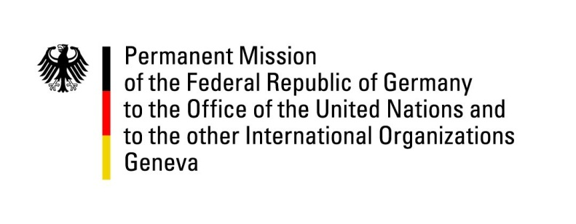

United Nations Human Rights Council

35th Session of the UPR Working Group

Geneva, 29 January 2020

Recommendations and advance questions to
Kuwait

Mr. President,

Germany welcomes the delegation of Kuwait to the third cycle of the UPR. Germany welcomes the ongoing cooperation between the government of Kuwait and international human rights organisations. In particular, we encourage Kuwait to continue to cooperate with the United Nations human rights institutions and mechanisms, including by accepting visit requests from Special Procedures mandate holders and by implementing their recommendations.
Germany recommends:
- Amend and repeal all laws and policies restricting freedom of opinion and expression in line with international standards and protect human rights defenders, journalists and bloggers against persecution and harassment.
- Accelerate the legislative process to resolve the Bidoon issue, by granting Kuwaiti citizenship to Bidoon people, ensure non-discriminatory access to social services to Bidoon people in Kuwait and guarantee that Bidoons can exercise their rights to freedom of movement, peaceful assembly, opinion and expression.
- Reinstate a moratorium on the death penalty with a view to its complete abolition.
- Abolish the provisions set out in articles 153, 197 of the Criminal Code; and create effective and independent complaints mechanisms for reporting sexual and domestic violence.
- Develop an effective and independent complaints mechanism to report on human rights abuses.
Thank you, Mr. President.

GERMAN ADVANCE QUESTIONS to KUWAIT:
- During the last cycle of the UPR, the Government of the State of Kuwait announced to revoke the Khafala sponsorship system and replace it with new regulations in accordance with international standards. What steps has the government of the State of Kuwait undertaken to implement this policy?
- What concrete measures is the Government of the State of Kuwait planning to protect female domestic workers effectively against abuse? What concrete measures has the Government of the State of Kuwait taken against the confiscation of domestic workers´ passports by the sponsors?
- What steps has the Government of the State of Kuwait taken to ensure the guarantee of freedom of expression which is an integral part of the Constitution of Kuwait, in particular with regard to social media usage, journalists and human rights defenders?
- Could the Government of the State of Kuwait inform us on the draft law on the Bidoons, its content and framework?
- How does the government plan to review the Nationality Act with regard to gender discrimination, specifically Kuwaiti women’s rights to transfer nationality to their children and to ensure equality between men and women with regard to the acquisition, change and retention of nationality?

