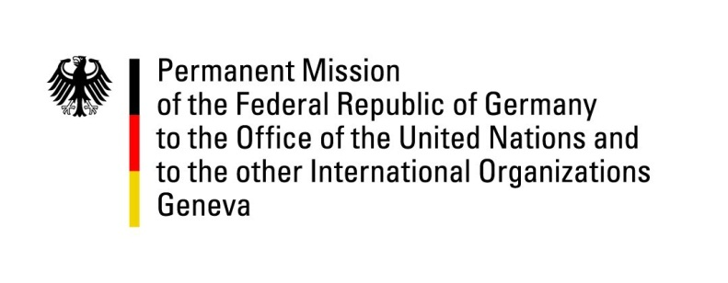

United Nations Human Rights Council

35th Session of the UPR Working Group

Geneva, 28 January 2020

Recommendations and advance questions to
Kiribati

Madam/Mr. (Vice) President,

Germany welcomes Kiribati’s ratification of the Convention against Torture in 2019 and the adoption of the Kiribati National Disability Policy in 2018.

Germany recommends to:
- Ratify the International Covenant on Civil and Political Rights (ICCPR) and its Optional Protocols, the International Covenant on Economic, Social and Cultural Rights (ICESCR) and the International Convention for the Protection of All Persons from Enforced Disappearance (ICPPED.)
- Strengthen the independence of the National Human Rights Task Force so that it complies with the Paris Principles.
- Decriminalize homosexuality and consensual sexual relations between adults of the same sex.
- Ensure gender equality, inter alia by reforming the Citizenship Act 1979 to ensure equal rights for Kiribati women to confer nationality to children and spouses on an equal basis to men.
- Ensure the effective implementation of the Family Peace Act.
- Ensure the freedom of opinion and expression including for journalists.

Thank you, Madam/Mr. (Vice) President.
GERMAN ADVANCE QUESTIONS TO KIRIBATI:
- How was civil society involved in the preparation of the national report?
- How many cases of domestic violence have been prosecuted since the entry into force of the Family Peace Act and how many cases have ended with criminal convictions?
- What steps is Kiribati undertaking to eliminate sexual and gender based violence?
- We are alarmed by foreign journalists facing restrictions when reporting on specific political topics or climate change. What measures has and will Kiribati undertake to ensure freedom of the press?

