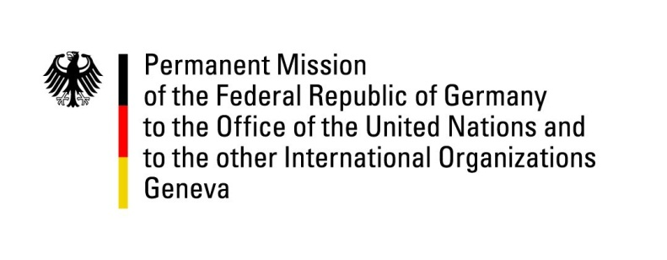

United Nations Human Rights Council

35th Session of the UPR Working Group

Geneva, 29 January 2020

Recommendations and advance questions to
Guyana

Thank you Mr. / Madame (Vice) President,
Germany commends Guyana on its commitment in the area of human rights and especially welcomes the adoption of a national policy on child labor in 2019 and the prohibition of corporal punishment of children in the penal system. However, Germany remains concerned that the use of corporal punishment is still lawful in many areas of public and private life.

Germany also notes the increase in women’s labor force participation and welcomes the ongoing consultations to formalize access to social security benefits for women in the informal sector. However, we remain concerned about the underrepresentation of women, especially indigenous women and women with disabilities.

Regarding the upcoming elections on March 2 Germany expresses the expectation that these will be fair, transparent and peaceful, so that the electorate of Guyana can exercise their legitimate right to vote under safe and secure conditions.

Germany therefore recommends to:
1. Ensure a transparent, fair and peaceful electoral process at the general elections on 2 March.
2. Prohibit corporal punishment of children both in public and private life in accordance with article 19 of the CRC.
3. Take measures to increase women’s participation in the active labor force and reduce the vertical and horizontal segregation in employment.

Thank you, Mr./ Madame (Vice) President.

