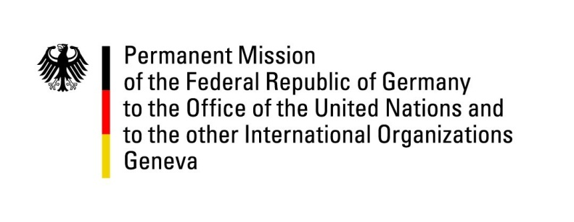

United Nations Human Rights Council

35th Session of the UPR Working Group

Geneva, 24 January 2020

Recommendations and advance questions to
Guinea - Bissau

Thank you Madame President,

Germany welcomes the delegation of Guinea - Bissau.
Germany commends Guinea-Bissau for progress made towards gender equality with the adoption of the parity act.
However, Germany remains concerned about ongoing human rights violations, especially concerning women`s and children`s rights, and about the fact that human rights violations committed by members of the military from 2012 to 2014 have not been investigated.

Germany recommends:
- Enhance measures to counter trafficking in human beings and organized crime. Strengthen the relevant national law enforcement and institutions of justice and ensure they can work independently and free of political influence.
- Provide an adequate budget for the administration of justice and accelerate reforms of the justice sector in order to ensure the independence of the judiciary and better accessibility of the court system.
- Take effective measures against social stigmatization of victims of sexual and gender based violence and ensure prosecution of perpetrators.
- Allocate an adequate budget to the education sector and take meaningful measures to increase school enrolment rates particularly in rural areas and of girls.

Thank you, Madame President.

GERMAN ADVANCE QUESTION TO Guinea-Bissau:
- What measures is the government planning to take in order to further strengthen the combat against organized crime and drug trafficking in particular?
- What measures is the government planning to take in order to strengthen the combat against child trafficking for the purpose of forced labour and sexual exploitation?
- What are the government’s priorities in relation to justice sector reforms? What measures are planned to enhance judicial independence and access to justice?
- What measures is the government taking against gender-based violence, especially to effectively implement the prohibition of Female Genital Mutilation practices and of child marriage?

