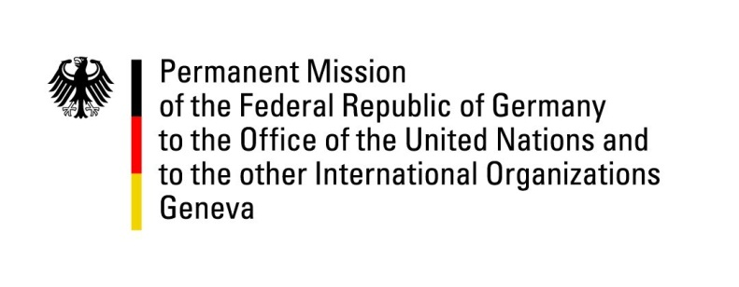

United Nations Human Rights Council

35th Session of the UPR Working Group

Geneva, 21 January 2020

Recommendations and advance questions to
Guinea

Mr. President,

Germany welcomes the delegation of Guinea to the UPR.

Germany welcomes the fact that capital punishment is no longer part of the revised criminal law. Germany remains concerned about ongoing restrictions of the rights to peaceful assembly and freedom of expression and about the fact that recommendations accepted during the past UPR cycle in this regard lack implementation.

Germany recommends:
- Ensure the full realization of civil and political rights for all, including the rights of peaceful assembly, demonstration and free expression.
- Ratify the Second Optional Protocol to the International Covenant on Civil and Political Rights on the abolition of the death penalty.
- Take urgent and meaningful measures to improve prison conditions in line with the UN Nelson Mandela Rules for the Treatment of Prisoners, especially with regard to overcrowding, access to food, water, sanitation facilities and medical treatment.
- Amend legislation in order to criminalize marital rape and take meaningful measures to ensure that the perpetrators of enforced marriage, rape and gender-based violence, including genital mutilation, are brought to justice in fair trials.
- Take effective measures to ensure an effective criminal prosecution, especially with regard to the most serious crimes, including training and the provision of sufficient human resources and equipment to judicial authorities.
- Take effective measures to eliminate remaining barriers to a full judicial investigation of the violations committed on 28 September 2009.

Thank you, Mr. President.
GERMAN ADVANCE QUESTION TO Guinea:
- Has the ban on demonstration expressed by the Minister of the Interior in 2018 been lifted meanwhile? In how far was/is this ban in accordance with Article 10 of the Guinean Constitution?
- What are the reasons for the continuing delays in the criminal prosecution of the suspected perpetrators of the massacre in September 2009 with more than 150 casualties and over 100 victims of rape? What meaningful efforts does the government take to advance legal prosecutions?
- Which measures has the government taken or intends to take to more effectively prevent genital mutilations? Why are perpetrators most often not persecuted, although genital mutilation is prohibited by law?

