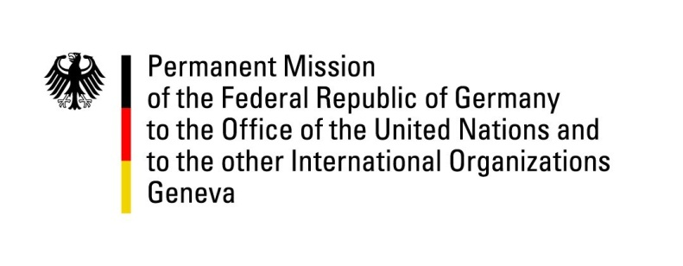

United Nations Human Rights Council

35th Session of the UPR Working Group

Geneva, 20 January 2020

Recommendations and advance questions to
Grenada

Thank you Mister President,
Germany welcomes the delegation of Grenada.

Germany congratulates Grenada on the ratification of the UN Convention against Torture in October 2019.
Germany further notes the establishment of a Committee on the Prevention of Child Sexual Abuse and the Establishment of a Special Victims Unit by the Royal Grenada Police Force.

Despite the de facto moratorium, Germany however remains concerned about the continuous existence of the death penalty and in particular that Grenada still has one prisoner on death row.
Furthermore, Germany remains concerned that LGBTI people continue to face discrimination, abuse and violations in public and private life.

Germany therefore recommends to:

1. Formalize the de facto moratorium on the death penalty by abolishing it in law and to ratify the Second Optional Protocol to ICCPR.
2. Introduce legislation prohibiting discrimination on the grounds of sexual orientation and gender identity.

Thank you, Mister President.
GERMAN ADVANCE QUESTIONS TO GRENADA:
- Since the review in 2015, there has been no change with regard to the legality of corporal punishment of children. What steps are being taken to fulfil Grenada’s obligation under international human rights law to prohibit all corporal punishment of children?
- Discrimination on the grounds of sexual orientation and gender identity remains an issue within society. Which steps does the government take to promote a constructive dialogue on human rights education and anti-discrimination awareness with stakeholders, including government ministries, civil society and religious leaders?

