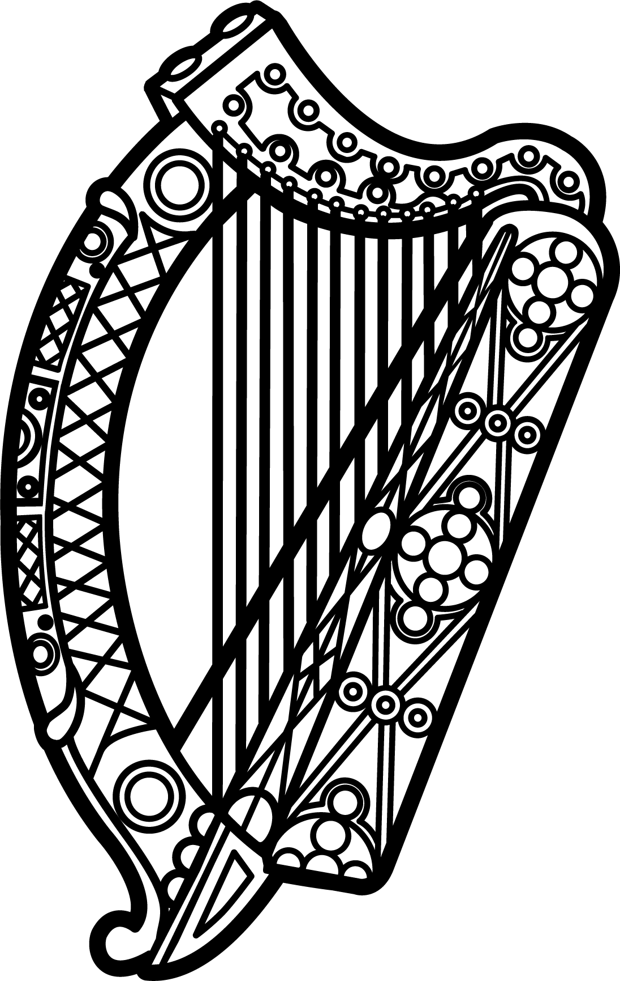

Statement of Ireland
35th session of the UPR Working Group

Review of Turkey

28 January 2020

Thank you, Mr (Vice) President.

Ireland warmly welcomes the delegation of Turkey and thanks them for their presentation.

We welcome the efforts of Turkey on certain issues, such as children's rights, since the last UPR cycle.

Ireland remains concerned by continued pressure on the rule of law and on civil society space.

Ireland makes the following recommendations to the Turkish authorities:

- Ensure the creation of a safe, enabling environment for journalists, human rights defenders and civil society both online and offline.

- Ensure that the application of anti-terror legislation is fully consistent with Turkey’s human rights obligations and international standards and ensure that those arrested on terror-related charges are afforded due process.

We wish Turkey every success with this UPR cycle.

Thank you.

