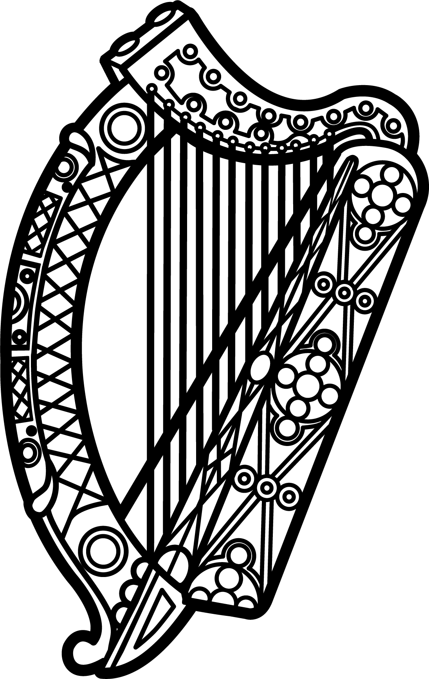

Statement of Ireland
35th session of the UPR Working Group

Review of Sweden

27 January 2020

Thank you, Mr (Vice) President.

Ireland warmly welcomes the delegation of Sweden and thanks them for their presentation.
Ireland welcomes Sweden’s efforts to advance human rights domestically and commends progress made since the last UPR cycle, particularly the Swedish Parliament’s decision to incorporate the UN Convention on the Rights of the Child into national law as of 1 January 2020. Sweden is a global leader in promoting human rights internationally, and Ireland commends Sweden for its contribution to the promotion and protection of human rights in multilateral fora.

Ireland makes the following recommendations to the Swedish authorities:

- Establish a National Human Rights Institution (NHRI), in accordance with the Paris Principles.
- Ratify the third Optional Protocol to the Convention on the Rights of the Child on a communications procedure.

We wish Sweden every success with this UPR cycle.

Thank you.

