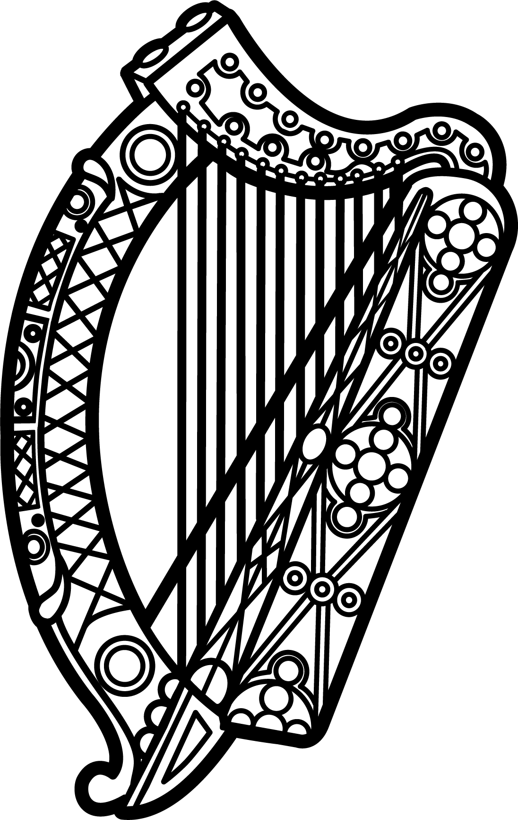

Statement of Ireland
35th session of the UPR Working Group

Review of Lesotho

22 January 2020

Thank you, Madam President.

Ireland warmly welcomes the delegation of Lesotho and thanks them for their presentation.

Ireland acknowledges Lesotho’s efforts to advance human rights domestically and notes progress made since the last UPR cycle.

Ireland recognises that the current national reform process will be important for the further promotion of human rights, and encourages Lesotho to continue efforts to strengthen the effectiveness of the National Human Rights Commission. Ireland encourages Lesotho to continue to cooperate with UN human rights mechanisms and to progress previous recommendations made by Ireland, particularly those with regard to reducing child mortality and gender discrimination.

Ireland makes the following recommendations to the Lesotho authorities:

- Take all necessary measures to formally abolish the death penalty, including removing the death penalty from the Constitution of Lesotho and by ratifying the second Optional Protocol to the International Covenant on Civil and Political Rights.

- Adopt the 2018 Domestic Violence Bill into law and continue efforts to combat gender based violence in Lesotho.

We wish Lesotho every success with this UPR cycle.

Thank you.

