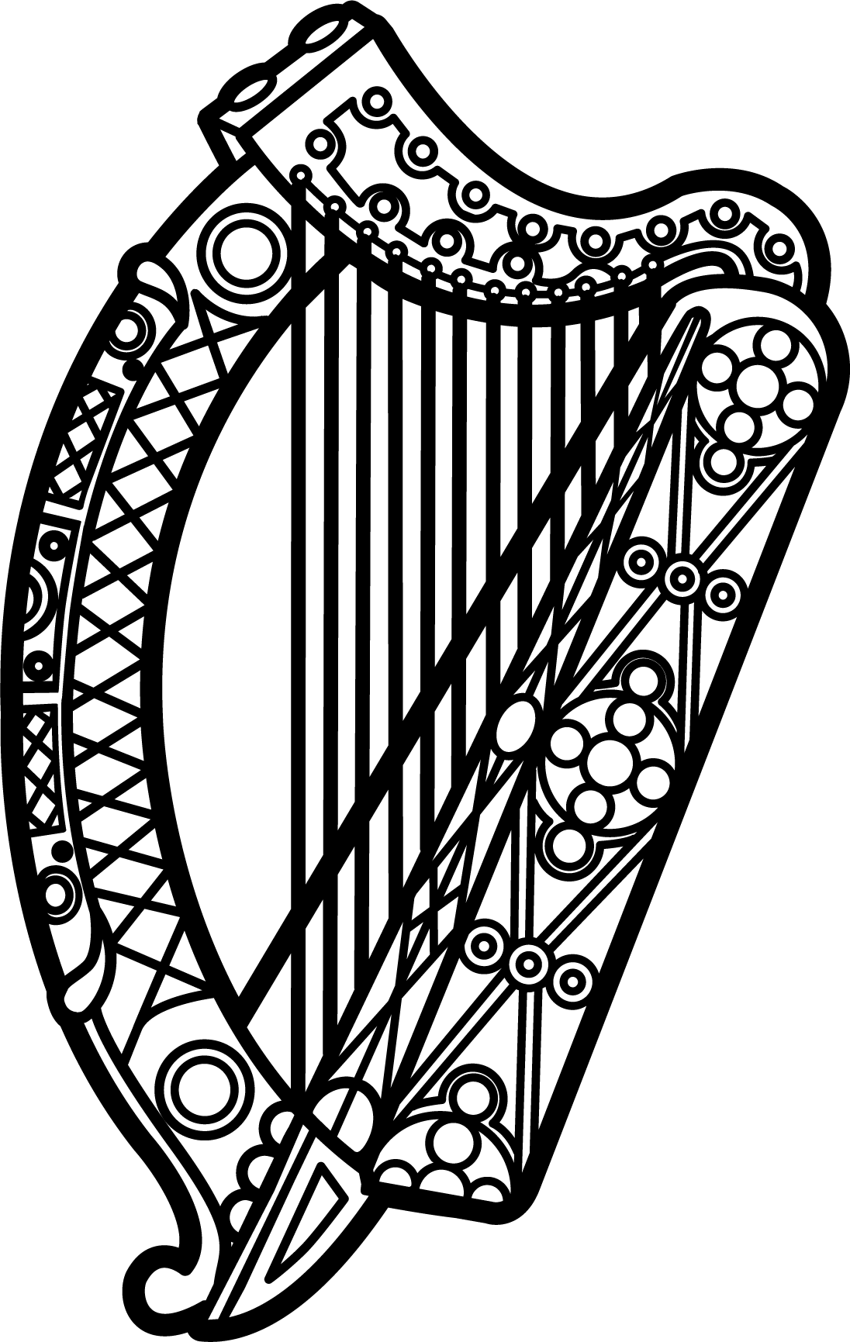

Statement of Ireland
35th session of the UPR Working Group

Review of Kuwait

29 January 2020

Thank you, Mr (Vice) President.

Ireland warmly welcomes the delegation of Kuwait and thanks them for their presentation.

Ireland acknowledges Kuwait’s efforts to advance human rights domestically and commends progress made since the last UPR cycle.

We welcome recent legislation providing for the establishment of a National Office for Human Rights, and call on Kuwait to establish this Office without delay and in accordance with the Paris Principles. Ireland also calls on Kuwait to establish a moratorium on the use of the death penalty.

Ireland makes the following recommendations to Kuwait:

- Accede to the 1961 convention on the reduction of statelessness and put in place a transparent process that addresses the concerns of the Bidoon people.

- Amend restrictive laws regulating the rights to association, peaceful assembly and freedom of expression, both online and offline, so that they are fully compliant with the ICCPR, particularly articles 19 and 21.

We wish Kuwait every success with this UPR cycle.

Thank you.

