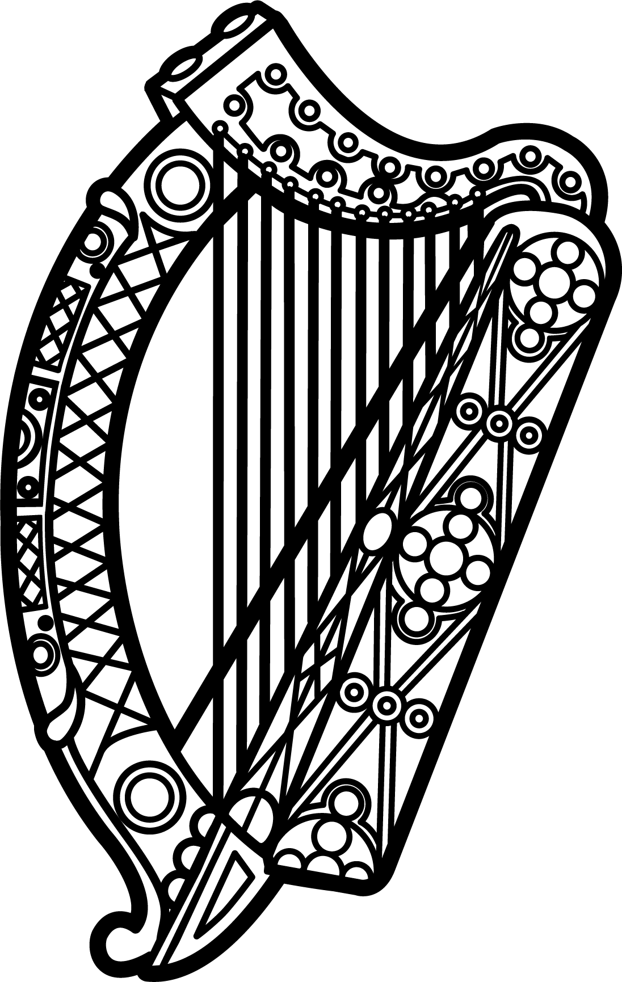

Statement of Ireland
35th session of the UPR Working Group

Review of Kiribati

28 January 2020

Thank you, Mr (Vice) President.

Ireland warmly welcomes the delegation of Kiribati and thanks them for their presentation.

Ireland commends Kiribati’s efforts to advance human rights domestically and for the leadership it has shown on climate change issues, in particular its initiation of the Coalition of Low-Lying Atoll Nations on Climate Change, and encourages their continued leadership on this global challenge. We recognise that Kiribati is one of the countries most affected by climate change, and facing growing threats to basic human rights of food and water security.

Ireland also welcomes Kiribati’s accession to the Convention Against Torture and the two Optional Protocols to the Convention on the Rights of Child. We encourage the Government of Kiribati to continue this progress and consider acceding to all other core human rights treaties to which Kiribati is not yet party as well as extending a standing invitation to all UN special procedures.

Ireland makes the following recommendations to the Kiribati authorities:

- Enact legislation covering all forms of violence against women (physical, sexual, trafficking, sexual harassment, stalking, psychological and economic).

- Intensify efforts to eliminate all forms of discrimination, including through broadening the definition of discrimination in the Constitution to align it fully with the Universal Declaration of Human Rights and core international human rights treaties.

We wish Kiribati every success with this UPR cycle.

Thank you.

