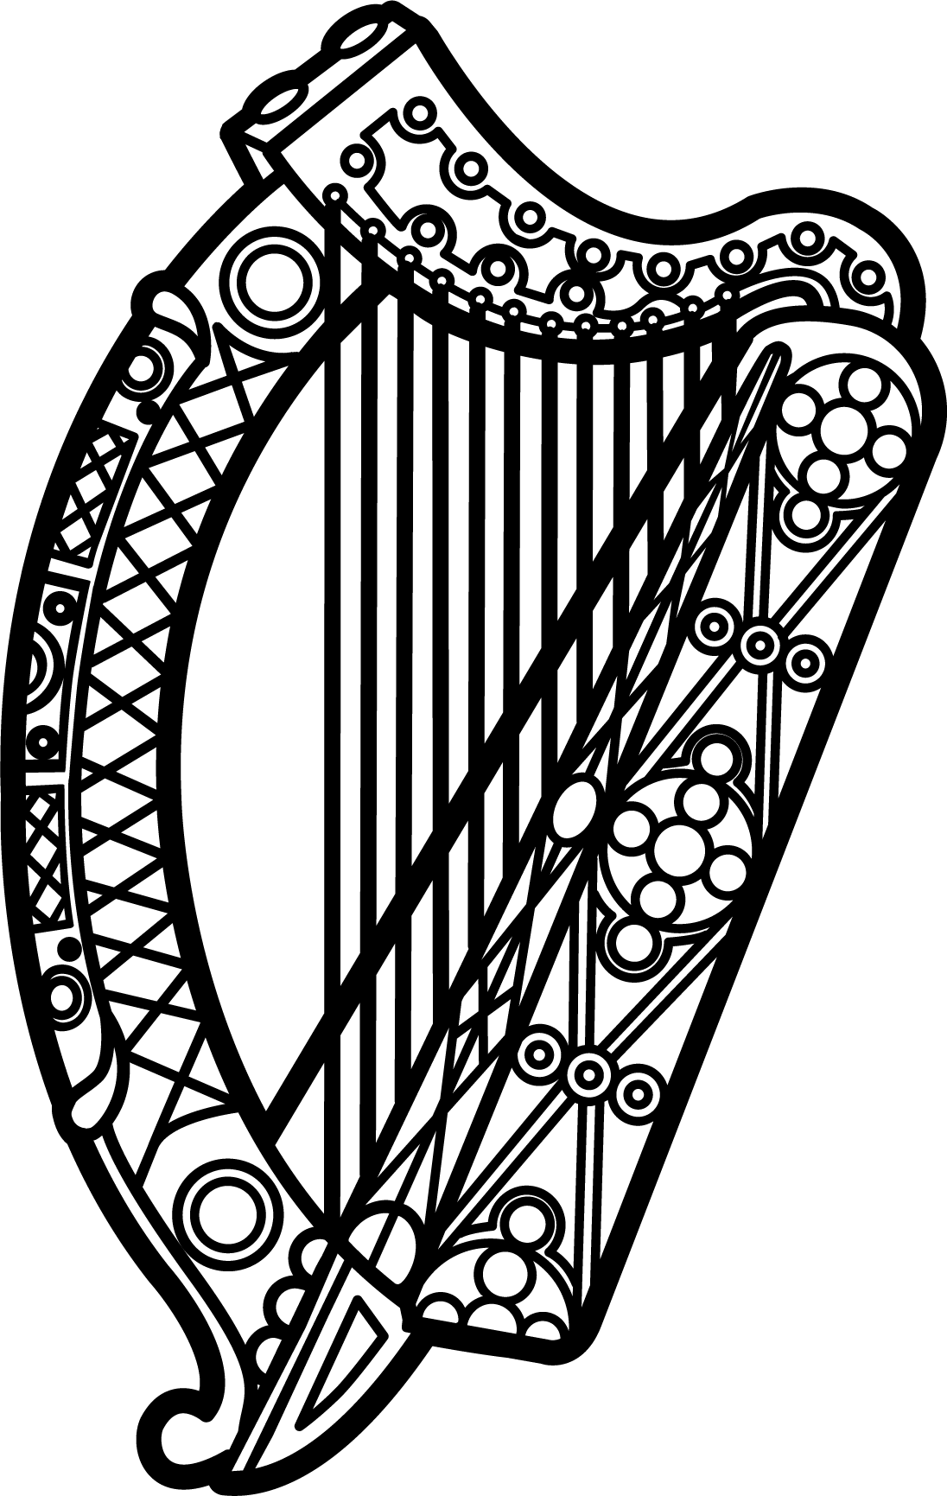

Statement of Ireland
35 session of the UPR Working Group

Review of Kenya

23 January 2020

Thank you, Mr (Vice) President.

Ireland warmly welcomes the delegation of the Republic of Kenya and thanks them for their presentation.

Ireland acknowledges Kenya’s efforts to advance human rights domestically and commends progress made since the last UPR cycle, including the adoption of the National Policy and Action Plan on Human Rights.

Ireland also welcomes the declaration by the Supreme Court of the unconstitutionality of the mandatory death penalty under section 104 of the Penal Code and the establishment of a working group by the government to make recommendations on this ruling. We urge Kenya to continue to work towards the full abolition of the death penalty.

Ireland makes the following recommendations to the Kenyan authorities:

- Develop and implement a comprehensive strategy to eliminate harmful practices, including child and forced marriage, female genital mutilation and sexual and gender-based violence, and harmful stereotypes that discriminate against women, and ensure that perpetrators are held accountable and that victims have access to effective remedies.
- Create and maintain, in law and in practice, a safe and enabling environment in which human rights defenders, including women human rights defenders, and civil society can operate free from hindrance and insecurity, including through the full operationalisation of the Public Benefits Organisation Act 2013.

We wish Kenya every success with this UPR cycle.

Thank you.

