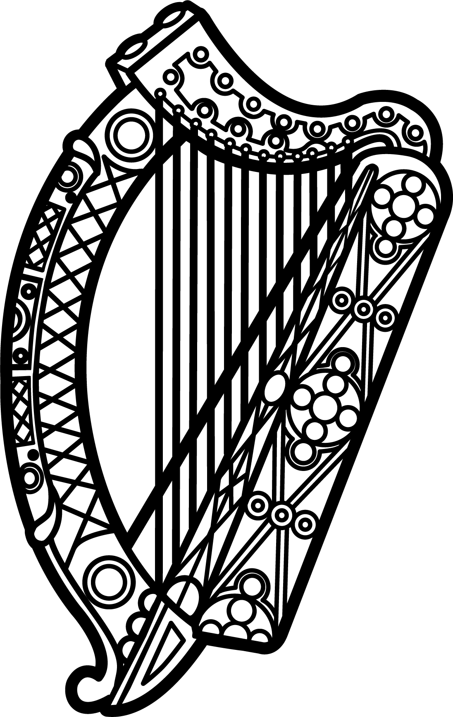

Statement of Ireland
35th session of the UPR Working Group

Review of Guyana
29 January 2019

Thank you, Mr (Vice) President.

Ireland warmly welcomes the delegation of Guyana and thanks them for their presentation.
Ireland welcomes the progress made in Guyana’s efforts to advance human rights domestically and commends progress made since the last UPR cycle, particularly in regard to the human rights of women and girls. Ireland welcomes the 2017-2021 National Plan of Action for the implementation of the 2010 Sexual Offences and Domestic Violence Act and the implementation of the 2017-2018 Anti-Trafficking National Plan of Action. However, despite these advances, Ireland remains concerned about the ongoing severity and widespread nature of gender violence in Guyana.
Further, Ireland encourages Guyana to establish an NHRI in accordance with the Paris principles.
Ireland makes the following recommendations to the Guyanese authorities:
- Repeal any legal provisions that discriminate against persons on the basis of their sexual orientation or gender identity and take all necessary steps to protect the LGBTI community from all forms of discrimination, including the decriminalisation of consensual same-sex conduct between adults.

- Take all necessary measures to abolish the death penalty, including the ratification of the Second Optional Protocol to the International Covenant on Civil and Political Rights.

We wish Guyana every success with this UPR cycle.
Thank you.

