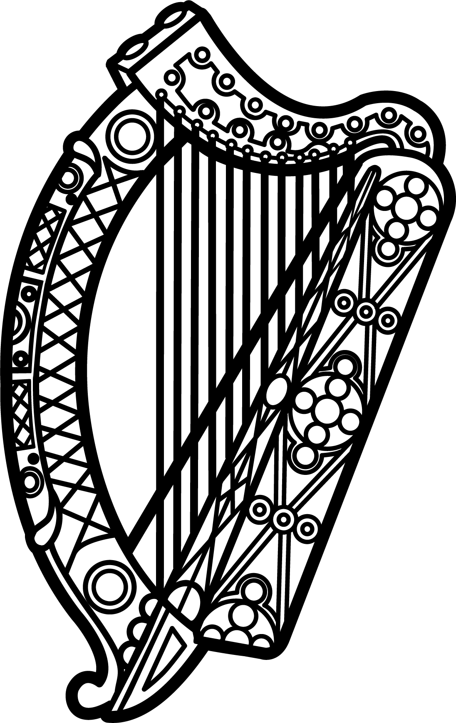

Statement of Ireland
35th session of the UPR Working Group

Review of Guinea-Bissau

24 January 2020

Thank you, Mr (Vice) President.

Ireland warmly welcomes the delegation of Guinea-Bissau and thanks them for their presentation.

Ireland acknowledges Guinea Bissau’s efforts to advance human rights domestically and commends progress made since the last UPR cycle. We hope that welcome progress on gender parity at Government level can be maintained.

Ireland also welcomes the progress made in the ratification of international treaties including the ratification of the Arms Trade Treaty and the Paris Agreement on climate change in 2018.

Ireland makes the following recommendations to the Guinea-Bissauan authorities:

- Create and maintain, in law and in practice, a safe and enabling environment for civil society and human rights defenders including by providing adequate protection for the right to freedom of expression and peaceful assembly and taking measures to decriminalise defamation and insult, and placing them within the Civil Code, in accordance with international standards.

- Effectively implement gender equality laws and policies protecting women’s rights including by engaging in outreach and education to change discriminatory and harmful traditional norms, stereotypes and practices, such as those concerning child, early and forced marriage; female genital mutilation and physical, psychological and sexual violence against women.

We wish Guinea-Bissau every success with this UPR cycle.

Thank you.

