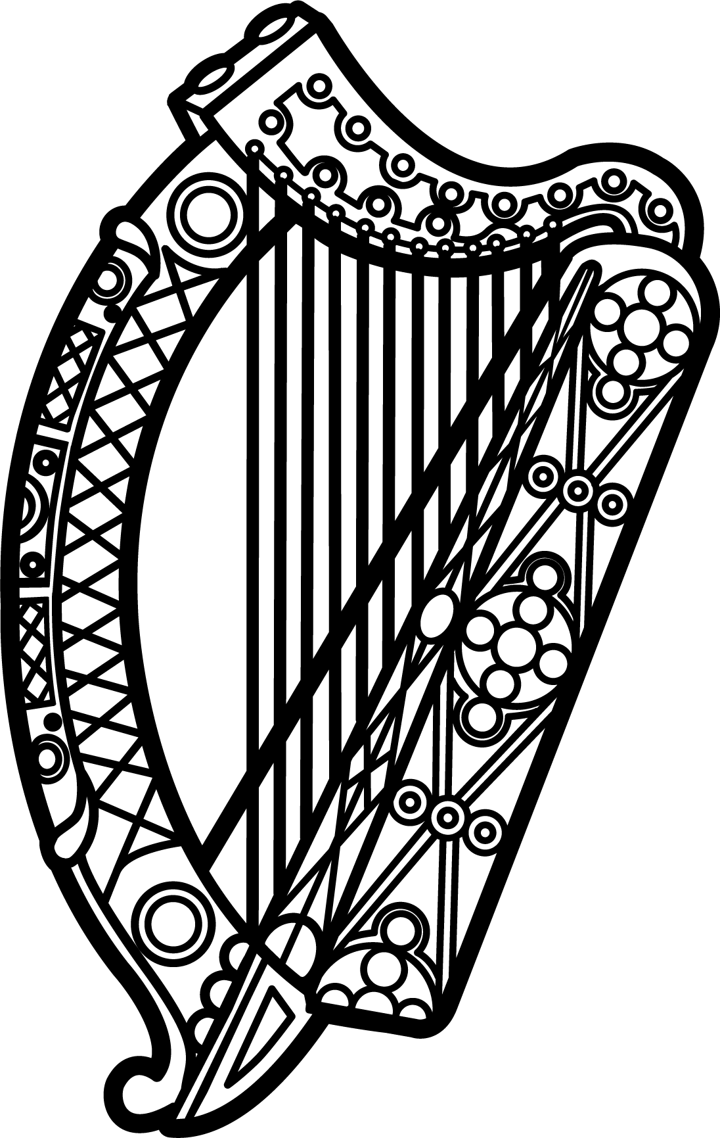

Statement of Ireland
35th session of the UPR Working Group

Review of Guinea

Tuesday, 21 January 2020
Thank you, Mr (Vice) President.

Ireland warmly welcomes the delegation of Guinea and thanks them for their presentation.

Ireland acknowledges Guinea’s commitment to advance human rights domestically and commends progress made since the last UPR cycle in January 2015, particularly the abolition of the death penalty. We hope to see existing death sentences commuted. Ireland also welcomes the criminalisation of torture in the revised Criminal Code; we urge Guinea to take further steps to prevent cases of torture and ill treatment.

Ireland makes the following recommendations to the Guinean authorities:

- Make every effort to hold free and fair elections, including the respect of citizen’s rights to freedom of expression and assembly, as guaranteed under Articles 19 and 21 of the International Covenant on Civil and Political Rights. Those responsible for the unlawful use of force against demonstrators should be appropriately investigated and held accountable.

- Take steps to combat and prevent all forms of gender-based violence, including enforcing the ban on child, early and forced marriage and the ban on female genital mutilation, and amending legislation to criminalise marital rape. All existing laws to prevent violence against women should be properly enforced and perpetrators should be held to account under appropriate judicial procedures.

We wish Guinea every success with this UPR cycle.

Thank you.

