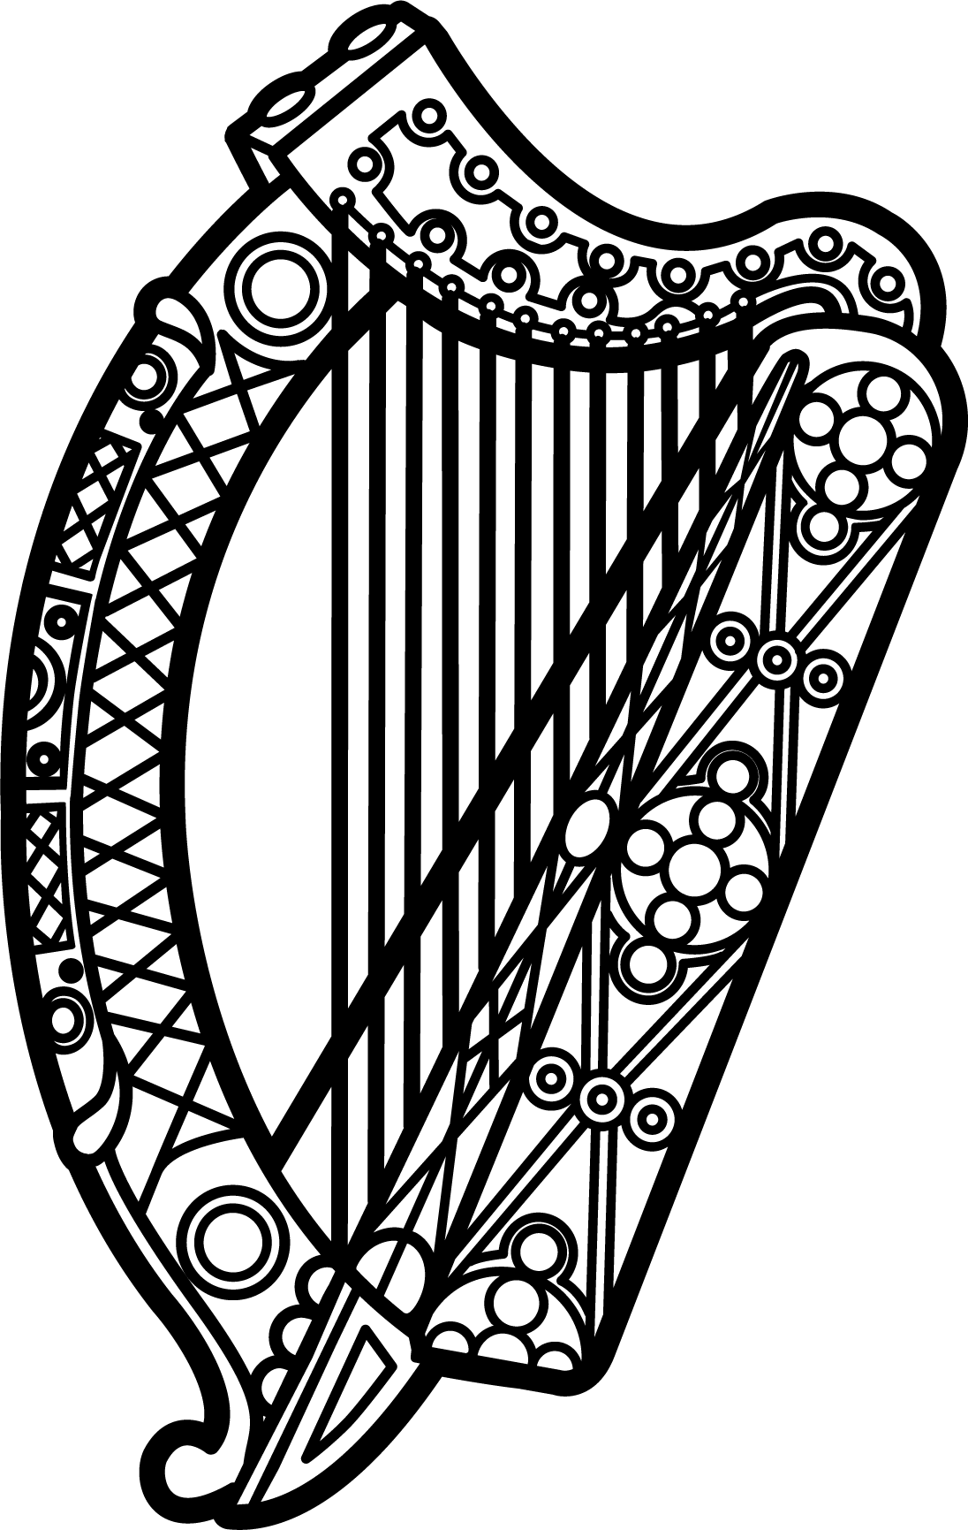

Statement of Ireland
35th session of the UPR Working Group

Review of Grenada

27 January 2020

Thank you, Mr (Vice) President.

Ireland warmly welcomes the delegation of Grenada and thanks them for their presentation.
Ireland commends progress made by Grenada since the last UPR cycle, including the ratification of the UN Convention against Torture and Other Cruel, Inhuman or Degrading Treatment or Punishment (UNCAT).
Ireland also welcomes efforts by Grenada to combat domestic violence and child abuse, including the establishment of a Committee on the Prevention of Child Sexual Abuse and the Special Victims Unit in the Royal Grenada Police Force with responsibility to respond to cases of intimate partner violence/, sexual violence and child abuse Ireland encourages Grenada to fulfil its commitment to establish an NHRI in compliance with the Paris principles.
Ireland makes the following recommendations to the Grenadian authorities:
- Ratify the Second Optional Protocol to the International Covenant on Civil and Political Rights, aiming at the abolition of the death penalty.

- Decriminalise consensual same-sex conduct between adults and take all necessary steps to protect the LGBTI community from all forms of discrimination on the basis of their sexual orientation and gender identity.

We wish Grenada every success with this UPR cycle.
Thank you.

