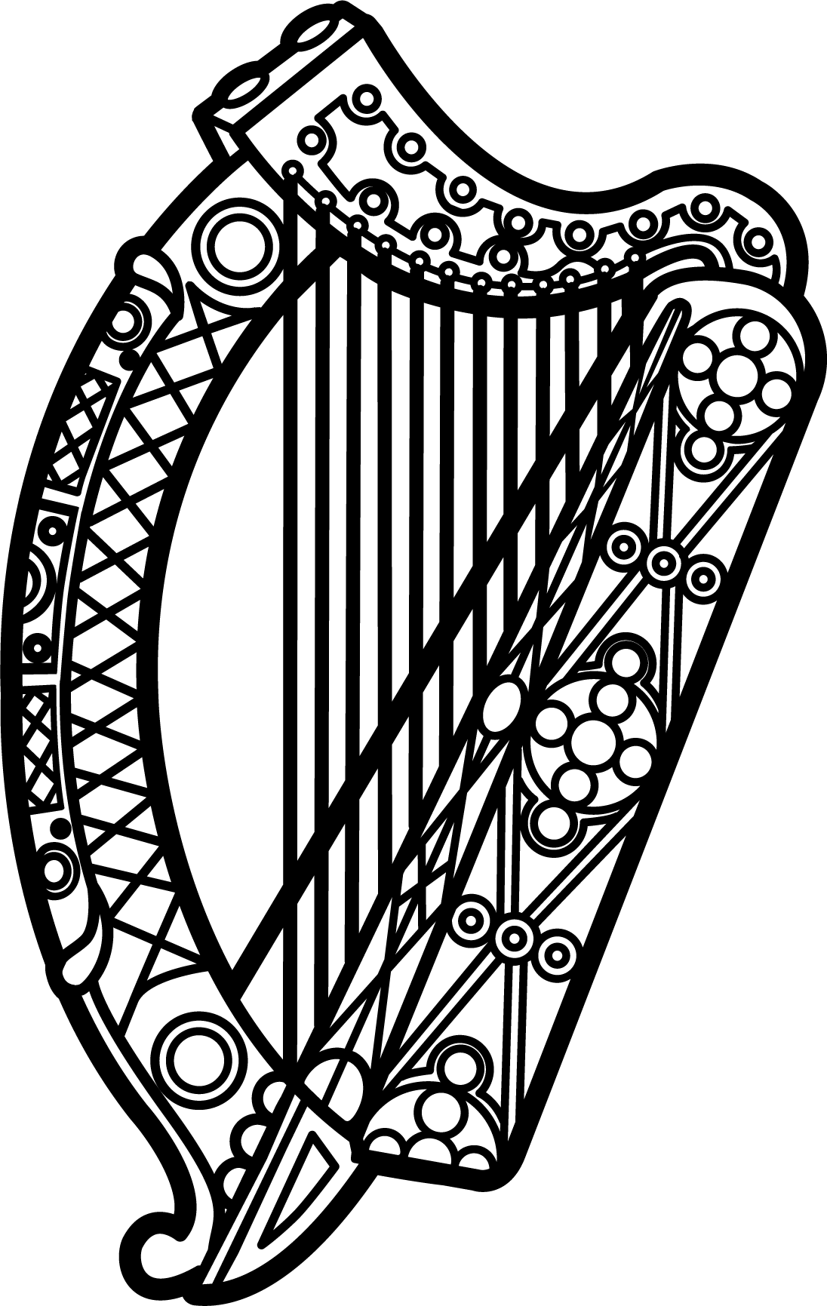

Statement of Ireland
35th session of the UPR Working Group

Review of Armenia

23 January 2020

Thank you, Madam President.

Ireland warmly welcomes the delegation of Armenia and thanks them for their presentation.

Ireland acknowledges Armenia’s efforts to advance human rights domestically and commends progress made since the last UPR cycle. Improvements regarding the conduct of free and fair elections, freedoms of assembly and expression, and freedom of the media are welcomed. Ireland also notes that Armenia is an internet freedom leader, ranking 8 out of 65 countries assessed in the most recent Freedom House survey.

Ireland watched the events of Spring 2018 in Armenia with great interest. We admire how the peaceful transformation has progressed steadily since then and appreciate the significant efforts being made in Armenia on reform across a number of areas such as economy, governance, democracy and human rights.

We remain concerned at alleged targeting of non-governmental organisations and human rights defenders seeking to address discrimination based on sexual orientation, gender identity and religious affiliation.

Ireland makes the following recommendations to the Armenian authorities:

- Strengthen protections for the right to freedom of association and peaceful assembly, including revising the current Law on Religious Organisations in line with recommendations of the Venice Commission.

- Close legislative gaps to ensure all forms of torture and ill-treatment are fully criminalised and take steps to eradicate torture and ill-treatment, and effectively investigate, prosecute and punish such acts.

We wish Armenia every success with this UPR cycle.

Thank you.

