[Check against delivery]

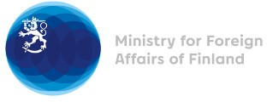

35 Session of the UPR working group Recommendations by Finland to Kenya

23 January 2020

Madame President,

Finland wishes to thank Kenya for its national report.

Finland wishes to make the following three recommendations:
- First, Finland recommends Government of Kenya to take concrete actions to ensure access to health services, information, and to review relevant laws and policies in order to ensure sexual and reproductive health and rights for all

- Second, Finland recommends that Kenya take further measurable efforts to combat corruption, including by ensuring thorough and effective investigation, prosecution of all suspects, and punish perpetrators

- Third, Finland recommends Kenya to enhance human rights training and awareness for law enforcement officials’ to end all violations, including excessive or arbitrary use of force and extra-judicial killings; and bring all responsible for human rights violations into justice as well to continue Police reforms

Thank you.

