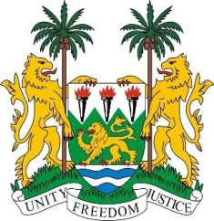

35th SESSION OF THE UPR

GUINEA-BISSAU

24 JANUARY 2020

Madam President,

Sierra Leone welcomes the distinguished delegation of Guinea-Bissau and thanks them for their constructive engagement with the UPR mechanism.

We commend the people of Guinea-Bissau for the peaceful and successful conduct of presidential election which marks an important step forward in the country’s democratic development.

We take this opportunity to congratulate President Umaro Cissoko Embalo and call on his Government to set out clear priorities on tackling poverty, corruption and international drug trafficking networks. We applaud actions taken against law enforcement agents who violate citizens’ rights.

My delegation encourages the new administration to continue to fully cooperate with the UPR mechanism.

My delegation makes the following recommendations for due consideration:

- Legislate and enforce laws aimed at combating corruption and transnational crimes
- Strengthen efforts to reform the judiciary and security sectors
- Accelerate efforts to ratify the OP-CAT

Sierra Leone wishes Guinea-Bissau every success in completing its third review cycle.

Thank you, Madam President.

