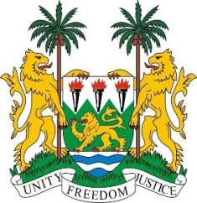
SIERRA LEONE

35th SESSION OF THE UPR

Turkey

28 JANUARY 2020

Madam President,

Sierra Leone warmly welcomes the Turkish delegation and its participation in the UPR process.

My delegation wishes to underline the comprehensive reform process Turkey has undertaken aimed at amending the legal framework on human rights, the rule of law and democracy in line with international standards.

We particularly laud the strong political will to revitalize the reform process with respect to the judiciary and fundamental rights and freedoms. The new Judicial Reform Strategy; and the development of new Action Plan on Human Rights are indeed commendable.

Sierra Leone also welcomes Turkey’s strong engagement in humanitarian efforts- the provision of humanitarian aid as well as the "Open Doors" policy adopted by the Turkish Government.

In view of those significant achievements and to encourage Turkey to further enhance its efforts, Sierra Leone would like to make the following recommendations:

- Take effective measures to ensure that the new National Human Rights Action plan fully embraces the recommendations accepted by Turkey in the UPR
- Adopt comprehensive reforms towards redressing gender injustice and inequality

Finally, Sierra Leone wishes Turkey a successful review.

Thank you, Madam President

