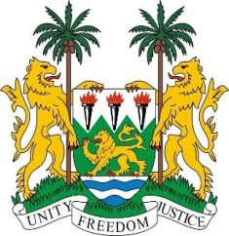
SIERRA LEONE
35th Session of the UPR

LESOTHO

22 JANUARY 2020

Mr President,

Sierra Leone welcomes the distinguished delegation of the Kingdom of Lesotho and thanks them for their presentation.

We commend the Kingdom of Lesotho for the significant strides made in achieving the SDG 1 and 10, addressing poverty, and reducing inequality respectively.

We particularly note with appreciation the emphasis placed by the country to promote gender equality and congratulates it for winning the 2016 African Gender Award.

In a spirit of constructive engagement, my delegation makes the following recommendations:

- Accelerate the process of accession to the Optional Protocol to the Convention against Torture and other Cruel Degrading Inhuman or Treatment or punishment.
- Adopt effective legislative measures to combat gender-based violence.
- Establish a mechanism to ensure timely reporting and follow up on the implementation of recommendations from the various treaty bodies.

Sierra Leone wishes the Kingdom of Lesotho every success in completing its third review cycle.

Thank you, Mr President.

