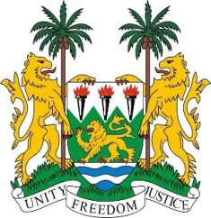

SIERRA LEONE

35th SESSION OF THE UPR

GUINEA

21 JANUARY 2020

Mr President,

Sierra Leone welcomes the distinguished delegation of the Republic of Guinea and thanks them for their presentation.

We commend the Government of Guinea, which is one of our closest and most intimate neighbours, for the regulatory framework it has put in place to address a number of harmful traditional practices.

My delegation, however, notes with concern reports of civil unrest relating to the political process, and urge all sides to protect public property and to respect the human rights of citizens and all residents of Guinea. The safety and security of ordinary people should be guaranteed at all times.

Recommendations:

- Accelerate reform of the security sector, with an emphasis on its respect for human rights, including the right to assembly
- Accelerate efforts to ratify both OP-ICESCR and the CEDAW
- Establish a specialised rehabilitation centre for minors in conflict with the law

Sierra Leone wishes the Republic of Guinea every success in completing its third review cycle.

Thank you, Mr President.

