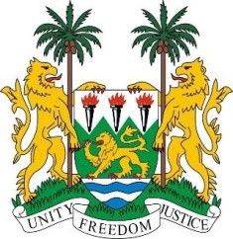
SIERRA LEONE

35th Session of the UPR

KENYA

23 January 2020

Mr President,

Sierra Leone warmly welcomes the delegation of Kenya to 35th UPR session
We take note of the significant progress Kenya has made in implementing recommendations from the 2nd UPR cycle. In particular we applaud the constructive legislative changes relating to freedom of expression, including the enactment of the Access to Information Act 2016 and a series of significant judicial decisions that repealed restrictive legislations.

Sierra Leone wishes to recommend to Kenya the following:
- Consider ratifying those international human rights instruments that it had not yet ratified, including ICRMW
- Continue its efforts towards reforming its human rights institutions and developing additional measures to ensure the effective implementation of their mandate
- Continue strengthening counter-terrorism measures as per its constitution and international standards

We wish Kenya a successful review and adoption of their UPR report.
I thank you!

