[Check against delivery]

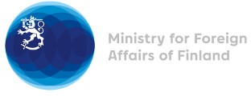

35 Session of the UPR working group Recommendations by Finland to Kyrgyzstan

20 January 2020

Madame President,

Finland wishes to thank Kyrgyzstan for its national report.
Finland wishes to make the following four recommendations:
- First, Finland recommends that the Government of Kyrgyzstan establish concrete and measurable steps to strengthen national human rights institution, the Ombudsman and the National Center for the Prevention of Torture and Other Cruel, Inhuman, Degrading Treatment or Punishment.
- Second, Finland recommends to take further legal and practical measures to combat all forms of violence against women and domestic violence, including forced marriages
- Third, Finland recommends to take concrete actions to ensure minority rights and efficiently combat all forms of discrimination, including persons with disabilities and LGBTI persons
- Fourth, Finland recommends, to immediately release human rights activist Azimjon Askarov in line with the view of the UN Human Rights Committee given in 2016

Thank you.

