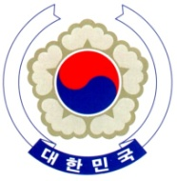

PERMANENT MISSION OF THE REPUBLIC OF KOREA
GENEVA

The 35th Session of the UPR Working Group <Check against delivery>
Review of Kuwait
Geneva, 29 January 2020

Statement of the Republic of Korea

Thank you, Madam President.

The Republic of Korea warmly welcomes the delegation of Kuwait.

We recognize the progress made since its last review and especially welcome legal and institutional developments concerning the rights of migrant workers, women and persons with disabilities. We also appreciate Kuwait’s humanitarian leadership and commitment to humanitarian-development cooperation.

With this in mind, we would like to make the following recommendations:

- Intensify efforts to raise awareness in the area of human rights and expand human rights trainings programmes for public and law enforcement officials;
- Consider taking additional steps to further promote the participation of women in public and political life; and
- Continue strengthening measures to improve the working and living conditions of migrant workers.

We wish Kuwait a successful review.

Thank you, Madam President.
/END/

