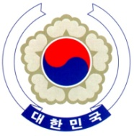

PERMANENT MISSION OF THE REPUBLIC OF KOREA
GENEVA

The 35th Session of the UPR Working Group <Check against delivery>
Review of Turkey
Geneva, 28 January 2020

Statement of the Republic of Korea

Thank you, Madam President.

The Republic of Korea warmly welcomes the delegation of Turkey to its third cycle of the UPR.

We commend Turkey on its generosity in accommodating a large number of refugees and asylum-seekers despite many difficulties in and out of the country. We also take note of its efforts to strengthen the judiciary through the constitutional amendment in 2017 and a series of reformative legislations last year.

In a constructive spirit, the Republic of Korea presents the following recommendations to Turkey:

- Continue to take necessary measures to ensure people’s full enjoyment of fundamental freedoms and human rights, in particular, in the civil and political domains; and

- Hold to account perpetrators of violence against women, including so-called honor crimes and domestic violence.

We wish Turkey a successful review. I thank you.
/END/

