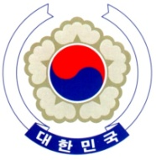

PERMANENT MISSION OF THE REPUBLIC OF KOREA
GENEVA

The 35th Session of the UPR Working Group <Check against delivery>
Review of Sweden
Geneva, 27 January 2020

Statement of the Republic of Korea

Thank you, Madam President.

The Republic of Korea warmly welcomes the Swedish delegation to its third cycle of the UPR.

We acknowledge Sweden’s continued efforts to implement the recommendations of its last UPR. In particular, we welcome the incorporation of the UN Convention on the Rights of the Child (CRC) into domestic law. We also note with appreciation the various measures taken by the Government of Sweden to promote gender equality and combat violence against women.

Bearing in mind the progress made, we would like to recommend the following:

- Step up efforts to combat discrimination against minorities and vulnerable groups, including indigenous peoples and migrants, and to promote tolerance in society; and
- Make continued efforts to establish an independent national human rights institution in compliance with the Paris Principles.

We wish Sweden a successful review.

Thank you, Madam President.
/END/

