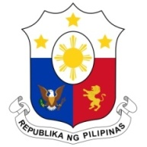
PHILIPPINES

Human Rights Council
35th Session of the Working Group on the Universal Periodic Review
Salle XX, Palais des Nations
28 January 2020

TURKEY
Speaking Time: 50 seconds
Speaking Order: 98th of 133

Thank you, Madam President.

The Philippines warmly welcomes the delegation of Turkey and conveys our condolences to the families of the victims on the recent earthquake.

My delegation notes the adoption of a number of policies and action plans, in particular on the right to education and those relating to women’s and children’s rights.

The Philippines recognizes Turkey´s proactive approach in sheltering millions of refugees and granting them with temporary protection without any form of discrimination.

In a constructive spirit, the Philippines presents the following recommendations for consideration by Turkey:

- Further strengthen measures to address and prevent domestic violence; and

- Continue to review and assess its immigration laws and policies to ensure that the rights of migrants are safeguarded in accordance with international human rights standards.

We wish Turkey a successful review.

Thank you, Madam President. END.

