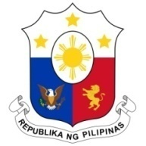
PHILIPPINES

Human Rights Council
35th Session of the Working Group on the Universal Periodic Review
22 January 2020, Salle XX, Palais des Nations

LESOTHO
Speaking Time: 1 min. 20 sec.
Speaking Order: 37 of 85

Thank you, Madam President.

The Philippines welcomes the delegation of Lesotho to this UPR session.

We note with appreciation the progress made by the government in implementing the UPR recommendations from the last cycle.

We recognize the adoption of national strategies that give due priority to the areas of inclusive and sustainable growth, socio-economic development, and strengthening governance and accountability.

In a constructive spirit, the Philippines recommends the following:

- Ensure the allocation of adequate resources to the Human Rights Commission;

- Continue to give due priority to vulnerable sectors in community-based disaster resilience and climate adaptation efforts;

- Further intensify the conduct of public awareness-raising activities on combating trafficking in persons; and

- Redouble efforts in strengthening policy measures and programs to prevent and address gender-based violence.

We wish Lesotho every success in this review cycle.

Thank you, Madam President. END.

