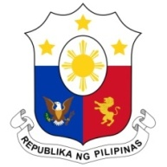
PHILIPPINES

Human Rights Council
35th Session of the Working Group on the Universal Periodic Review
29 January 2020, Salle XX, Palais des Nations

KUWAIT
Speaking Time: 55 seconds
Speaking Order: 84th of 127

Thank you, Mister Vice-President.

The Philippines warmly welcomes the delegation of Kuwait to this UPR session.

We note with appreciation the enactment of a number of policy measures to further advance the protection of rights of vulnerable groups including children and persons with disabilities.

In a constructive spirit, the Philippines presents the following recommendations for consideration:

- Continue to promote inclusive education in particular in rural areas;

- Take further steps to improve the protection of the rights of migrant workers including through effective enforcement of relevant laws and policies;

- Strengthen measures and mechanisms to monitor the employers’ compliance of the Domestic Workers Law; and

- Continue to ensure the implementation of its national strategy on combating trafficking in persons.

We wish Kuwait a successful review.

Thank you, Mister Vice-President. END.

