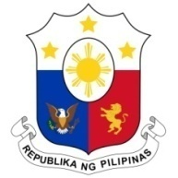
PHILIPPINES

Human Rights Council
35th Session of the Working Group on the Universal Periodic Review
23 January 2020, Salle XX, Palais des Nations

KENYA
Speaking Time: 55 sec.
Speaking Order: 64 of 120

Thank you, Madam Vice-President.

The Philippines warmly welcomes the delegation of Kenya and thanks them for the presentation of their report.

We commend Kenya for its efforts to strengthen policies and programs with regard to persons with disability, women, children, and other vulnerable groups.

In a constructive spirit, the Philippines recommends the following:

- Take further steps to promote access to technical, vocational and education training institutions especially by women and young people;

- Continue to implement its inclusive national framework on preventing and addressing sexual and gender-based violence; and

- Consider further measures to enhance the meaningful participation of indigenous peoples in all matters affecting them.

We wish Kenya a successful review.

Thank you, Madam Vice-President. END.

