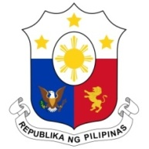
PHILIPPINES

Human Rights Council
35th Session of the Working Group on the Universal Periodic Review (UPR)
24 January 2020, Salle XX, Palais des Nations

GUINEA-BISSAU
Speaking Time : 1 min 30
Speaking Order : 9th of 79

Thank you, Madam Vice-President.

The Philippines warmly welcomes the delegation of Guinea-Bissau and thanks them for the presentation of their report.

My delegation acknowledges Guinea-Bissau’s efforts in implementing the recommendations from the last cycle.

We commend Guinea-Bissau for its ratification of the International Convention on the Protection of All Migrant Workers and Members of their Families in 2018.

In a constructive spirit, the Philippines presents the following recommendations for consideration:

- Further strengthen the implementation of poverty alleviation programs through partnerships with the international community;

- Take further steps to improve school enrolment and retention rate especially among girls in rural areas; and

- Ensure the effective implementation of its National Strategic Plan on Combating Drugs and Organized Crimes.

We wish Guinea-Bissau a successful review.

Thank you, Madam Vice-President. END

