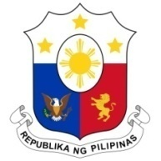
PHILIPPINES

Human Rights Council
35th Session of the Working Group on the Universal Periodic Review
21 January 2020, Salle XX, Palais des Nations

GUINEA
Speaking Time: 1 min. 20 sec.
Speaking Order: 14 of 87

Thank you, Madam President.

The Philippines warmly welcomes the delegation of the Republic of Guinea to this UPR session.

My delegation acknowledges the progress made by the government in implementing the UPR recommendations from the last cycle.

We recognize the commitment of the government to further strengthen its National Human Rights Institution by ensuring the allocation of sufficient resources.

We note with appreciation the adoption of a number of policy measures aimed to further strengthen the promotion and protection of the rights of women, children, and other vulnerable sectors.

In a constructive spirit, the Philippines recommends the following:

- Step up efforts in addressing the root causes of and vulnerabilities of women and children to gender-based violence;

- Continue to implement programs to strengthen the economic participation of women and young people; and

- Continue to enhance the human rights-based approach to the implementation of its National Economic and Social Development Plan.
We wish the Republic of Guinea every success in this review cycle.
Thank you, Madam President. END.

