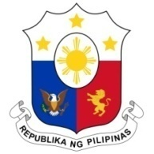
PHILIPPINES

Human Rights Council
35th Session of the Working Group on the Universal Periodic Review
23 January 2020, Salle XX, Palais des Nations

ARMENIA
Speaking Time: 1 min. 10 sec.
Speaking Order: 32 of 96

Thank you, Madam President.

The Philippines warmly welcomes the delegation of Armenia and thanks them for the presentation of their report.

We recognize Armenia’s constructive approach to the UPR process and welcome the implementation of its National Strategy for Human Rights Protection.

We note with appreciation Armenia’s committed efforts to reduce poverty and ensure an inclusive development.

In a constructive spirit, the Philippines recommends the following:

- Take further steps to ensure the full implementation of its law on the prevention of domestic violence;

- Consider further measures to promote the economic participation of women and young people; and

- Continue to enhance its programs on combating online child sexual exploitation and abuse.

We wish Armenia a successful review.

Thank you, Madam President. END.

