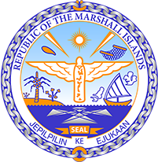

STATEMENT by Teri K. Elbon
Permanent Mission of the Republic of the Marshall Islands

RMI Recommendations to Angola
34th Session of the Universal Periodic Report Working Group
November 7, 2019 Geneva

Check against delivery
Mr. President
The Republic of the Marshall Islands welcomes the distinguished delegation of Angola and thanks them for the comprehensive national report.

We commend Angola’s strong commitment to improving the human rights situation which is demonstrated through the reduction of extreme poverty rate, on going implementation of state policies to promote gender equality, including signing and ratification of several International instruments on human rights. My delegation encourages the government of Angola to continue its positive efforts to achieve sustainable development.

It is in our view that better educational access and attainment not only equips women and girls with the skills to deal with the daunting effects of climate change, but it gives them influence over how their communities mitigate against it.

In this regard, we would like to recommend Angola to strengthen implementation of national policies and programs to improve the situation of women and girls and to ensure quality education for children, especially in rural areas.

To conclude, the Marshall Islands wishes Angola every success in this review.

Kommol tata and thank you.

