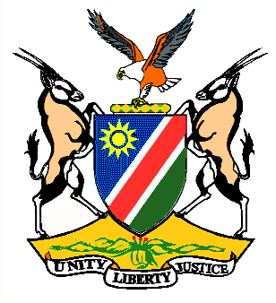

Statement by H.E. Penda A. Naanda, Ambassador/PR, during the Interactive Dialogue on the Universal Periodic Review of Italy 04 November 2019

Thank you, Mr. President,
- Namibia warmly welcomes H.E. Hon. Manlio Di Stefano, Under-Secretary of State for Foreign Affairs and International Cooperation of Italy, and his delegation to this UPR cycle. We congratulate them for presenting a comprehensive national report which clearly outlines the measures taken by Italy to implement the recommendations from the last review.
Mr. President,
- Among other significant anniversaries, the year 2020 will mark 20 years since the adoption of United Nations Security Council Resolution 1325. It is, therefore, an opportunity to take stock of the progress made but more importantly as the Secretary-General of the UN correctly points out in his recent report to the Security Council, it is an opportunity to close the remaining gaps that hinder the successful implementation of Resolution 1325.

- Namibia recognises that one of the issues that need close attention in this regard is the nexus between disarmament, non-proliferation and arms control and the Women, Peace and Security Agenda. We, therefore, make the following recommendation to Italy for consideration:

  - Take more measures to prevent arms transfers that may facilitate human rights violations, including gender-based violence, and that negatively impact women.

- We wish the delegation of Italy a successful review.

- I thank you Mr. President.

