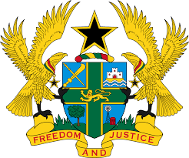

STATEMENT BY GHANA DELIVERED BY MS. ABA AYEBI-ARTHUR,
COUNSELLOR, TUESDAY 12TH NOVEMBER 2019

REVIEW OF SLOVENIA

Thank you, Mr. President
Ghana extends a warm welcome to the delegation of Slovenia to the UPR Working Group.
We commend the steps taken by the Government since the last UPR to promote and protect human rights, such as the adoption of several measures to reduce the level of poverty and social exclusion, and implementation of the Youth Guarantee Scheme.

To further strengthen human rights promotion and protection in Slovenia my delegation wishes to make the following three recommendations:

- Enact and fully implement legislations that seek to improve the current situation of the Roma minority;

- Enact a comprehensive legislation to address incidences of hate speech on social media and elsewhere and lastly;

- Consider instituting anti-poverty policies and programmes that would ensure the full protection and promotion of the rights of the child.

My delegation wishes Slovenia every success with the UPR.

I thank you.

