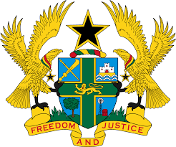

STATEMENT BY GHANA DELIVERED BY MS. ABA AYEBI-ARTHUR,
COUNSELLOR, MONDAY 11TH NOVEMBER, 2019

REVIEW OF MADAGASCAR

Thank you, Mr. Vice President
My delegation warmly welcomes the delegation of Madagascar to the UPR Working Group.
Ghana commends Madagascar for the progress made in the promotion and protection of human rights and the rule of law through implementation of strong institutional frameworks, policies and programmes.
We also note with commendation the recent ratification by Madagascar of a number of human rights treaties, including the Optional Protocol to the Convention against Torture and Other Cruel, Inhuman or Degrading Treatment or Punishment, and the Convention on the Rights of Persons with Disabilities.

Ghana wishes to make the following two recommendations:
- Continue to enact and fully implement legislations that seek to promote and protect the rights to freedom of expression and religion;

- Consider enacting a comprehensive legislation that provides full and effective protection against discrimination in all forms, and which contains a comprehensive list of prohibited offences that constitute grounds of discrimination;

Ghana wishes Madagascar a successful UPR.

I thank you.

