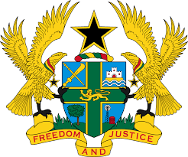

STATEMENT BY GHANA DELIVERED BY MS. ABA AYEBI-ARTHUR,
COUNSELLOR, MONDAY 11TH NOVEMBER 2019

REVIEW OF IRAQ

Thank you, Mr. President

Ghana extends a warm welcome to the delegation of Iraq to the UPR Working Group.

My delegation notes with appreciation the progress made by Iraq to develop human rights and institutional framework, including the establishment of a Human Rights Division in the Ministry of Justice, and a Women’s Empowerment Division at the Secretariat of the Council of Ministers.
We further commend the government for adopting numerous national strategies and plans aimed at promoting and protecting human rights, including the Poverty Reduction Strategy 2018-2022, and the National Strategy to build capacity among women in the Kurdistan Region.

Ghana has the following two recommendations:
- Ensure that the ongoing review of domestic laws guarantees gender equality and the rights of women and girls;

- Consider ratifying the Optional Protocol to the Convention against Torture and Other Cruel, Inhuman or Degrading Treatment or Punishment at the earliest convenience.

Ghana wishes Iraq a successful review outcome.

I thank you.

