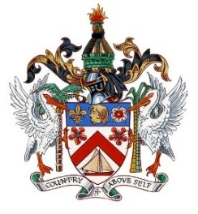
THE FEDERATION OF SAINT KITTS AND NEVIS

34th Session of the Universal Periodic Review
Statement by Sheldon Henry
Representative of St. Kitts and Nevis

Statement for:
Italy

04th November, 2019

Thank you Mr. President,

St. Kitts and Nevis would like to welcome the delegation of Italy to the UPR and notes with appreciation its achievement of implementing over 80% of its supported recommendations along with its remarkable efforts to cope with the massive influx of refugees to its shores. My delegation would like to make the following 2 recommendations.

- We recommend that it continues to Condemn all statements of a racist nature and increase awareness-raising, particularly directed at youth, of the unacceptability of racism.
- We recommend that it continues to implement measures to integrate and protect the most vulnerable groups among migrants and refugees.

We wish Italy a successful review. I thank you Mr. President

