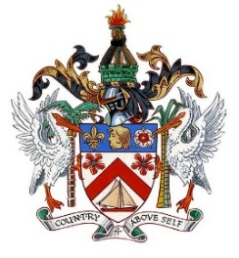
THE FEDERATION OF SAINT KITTS AND NEVIS

34th Session of the Universal Periodic Review
Statement by Sheldon Henry
Representative of St. Kitts and Nevis

Statement for:
The Republic of The Gambia

05th November, 2019

Thank you Mr. President

St. Kitts and Nevis welcomes the delegation of the Republic of The Gambia and commend it on the important measures adopted at its last UPR cycle. We note with appreciation its effort of reviewing all media laws and also its drafting of the Freedom of Information Bill.

My delegation would like to recommend that it tables and pass the Freedom of Information Bill soonest and continue to amend and ensure that its Information and Communications Act is in line with international best practices, which is linked to SDG 16.

We wish the Gambia a successful review. Thank you Mr. President.

