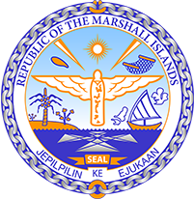

STATEMENT by H.E. Ambassador Doreen de Brum
Permanent Mission of the Republic of the Marshall Islands
Republic of Fiji Universal Periodic Review
34th Session of the Universal Periodic Report Working Group
November 6, 2019 Geneva

Check against delivery
Mr. President,
The Republic of the Marshall Islands warmly welcome and thank the distinguished delegation of Fiji and applaud the leadership of Fiji in the Human Rights Council. The Marshall Islands commends all the efforts of the Government of Fiji in its promotion and protection of human rights, in particular Fiji’s on going efforts towards combating climate change.
While recognizing Fiji’s efforts, the Marshall Islands would like to propose the following recommendations:
- To involve social inclusion of affected communities and disadvantaged groups in natural disaster management planning and policy, to ensure different needs, experiences, and contexts within society are taken into account.
- To accelerate current efforts towards ensuring disability-inclusive education and accessibility, within and around school grounds.
- To consider conducting a national dialogue on climate change, bringing together all stakeholders and the public, to outline priorities to mobilize domestic and global partners and align resources to the country’s most urgent needs. The Marshall Islands avails itself the opportunity to share its experiences with Fiji in this regard.
The Marshall Islands thanks the delegation once again, and wish Fiji the very best in this review.
Kommol tata and thank you.

